SR. | User Requirement | GPT Result | Our System Result
 | The Operator is already logged in. | Missing | 1. The system shall be able to logged operator already.
 | The Operator requests to view the status of a monitoring location. | 1 The system shall provide the Operator with the ability to request to view the status of a monitoring location. | 2. The system shall be able to requests operator view status monitoring location.
 | If an Emergency situation occurs then System displays emergency warning message to operator. | 8 If an Emergency situation occurs while the Operator is viewing the monitoring location status, then the system shall be able to display an emergency warning message to the Operator. | 3. If an emergency situation occurs then the system shall be able to occur displays emergency warning message to operator.
 | The system displays the monitoring status as follows: Sensor status for each sensor (value, upper limit, lower limit, alarm status). | 4 For each sensor, the system shall display the current sensor value. | 4. The system shall be able to display the monitoring status as follows sensor status for each sensor value , upper limit , lower limit , alarm status.
 | Monitoring status has been displayed. | 44 The system shall validate that the Operator is logged in before allowing access to monitoring status. | 5. The system shall be able to monitoring status displayed.
 | The Operator is logged in before starting the process. | Missing | 6. The system shall be able to logged operator starting process.
 | The Operator requests to view the outstanding alarms. | 9 The system shall provide the Operator with the ability to request to view outstanding alarms. | 7. The system shall be able to requests outstanding operator view alarms.
 | If an Emergency situation occurs then System displays emergency warning message to operator. | 15 If an Emergency situation occurs while the Operator is viewing outstanding alarms, then the system shall be able to display an emergency warning message to the Operator. | 8. If an emergency situation occurs then the system shall be able to occur displays emergency warning message to operator.
 | The system displays the outstanding alarms. | 10 The system shall be able to display a list of outstanding alarms upon request. | 9. The system shall be able to display the outstanding alarms.
 | For each alarm, the system displays the name of the alarm, alarm description, location of alarm, severity of alarm (high, medium, low). | 11 For each outstanding alarm, the system shall display the name of the alarm. | 10. The system shall be able to display the name of the alarm , alarm description , location of alarm , severity of alarm high , medium , low.
 | Outstanding alarms have been displayed. | The system shall validate that the Operator is logged in before allowing access to outstanding alarms. | 11. The system shall be able to displayed outstanding alarms.
 | The remote system is operational in advance. | Missing | 12. The system shall be able to operational in advance.
 | The sensors sends new monitoring data to the system. | 16 The system shall be able to receive new monitoring data from sensors. | 13. The system shall provide sensors with the ability to send new monitoring data to the system.
 | If an Emergency situation occurs then System displays emergency warning message to operator. | 22 If an Emergency situation occurs while updating monitoring status, then the system shall be able to display an emergency warning message to the Operator. | 14. If an emergency situation occurs then the system shall be able to occur displays emergency warning message to operator.
 | The system updates the monitoring status as follows: Sensor status for each sensor (value, upper limit, lower limit, alarm status). | 17 Upon receiving new monitoring data from sensors, the system shall update the monitoring status for each sensor. | 15. The system shall be able to update the monitoring status as follows sensor status for each sensor value , upper limit , lower limit , alarm status.
 | The system sends new monitoring status to Monitoring-Operators who have subscribed to receive status updates. | 23 The system shall be able to send updated monitoring status to Monitoring-Operators who have subscribed to receive status updates. | 16. The system shall be able to send new monitoring status to monitoring operators who subscribed to receive status updates.
 | Monitoring status has been updated. | 24 The system shall provide Monitoring-Operators with the ability to subscribe to monitoring status updates. | 17. The system shall be able to updated monitoring status.
 | If an alarm condition is detected then an alarm is generated. | 27 If an alarm condition is detected, then the system shall generate a new alarm. | 18. If an alarm condition is detected then the system shall be able to detect an alarm generated.
 | Operators are notified of new alarms to which they have subscribed. | 28 The system shall be able to notify Operators of new alarms to which they have subscribed. | 19. The system shall be able to notified new operators alarms which they subscribed.
 | If Emergency situation is detected then System displays emergency warning message to operator. | 31 If an Emergency situation is detected at any time, then the system shall be able to display an emergency warning message to the Operator. | 20. If emergency situation is detected then the system shall be able to display emergency warning message to operator.
 | The external sensor is operational already. | Missing | 21. The system shall be able to external operational sensor already.
 | The Remote Sensor sends an alarm to the system. | 32 The system shall be able to receive alarms from external remote sensors. | 22. The system shall be able to sends remote sensor alarm.
 | If the alarm is severe then a display with flashing warning is done. | 38 If the severity of a received alarm is high, then the system shall display the alarm with a flashing warning. | 23. If the alarm is severe then the system shall be able to be a display with flashing warning done.
 | The system updates the alarm data. | 33 Upon receiving an alarm from a remote sensor, the system shall update the alarm data. | 24. The system shall be able to update the alarm data.
 | The system stores the name of the alarm, alarm description, location of alarm, severity of alarm (high, medium, low). | 34 The system shall store the name of each alarm. | 25 The system shall be able to store the name of the alarm , alarm description , location of alarm , severity of alarm high , medium , low.
 | Alarm data have been updated. | 39 The system shall be able to display alarm data after it has been updated. | 26. The system shall be able to updated alarm data.
 | If the Operator is stuck somewhere in the process then he has an option to use help facility provided by the system. | 40 The system shall provide the Operator with the ability to access a help facility at any point in the process. | 27. If the operator is stuck somewhere in the process then the system shall be able to have he an option to use help facility provided by.
 | The Monitoring-Operator chooses help facility option | 41 The system shall display a message asking the Operator to select the type of help they want when the help facility is accessed. | 28. The system shall be able to chooses monitoring operator help facility option.
 | Screen displays a message asking the type of help he wants. | 42 The system shall provide the Operator with a list of help options to choose from. | 29. The system shall provide screen with the ability to display a message asking the type of help sensors wants.
 | Depending on the selection, the system helps him in proceeding with the system. | 43 Depending on the Operator’s selection, the system shall provide context-sensitive help to assist the Operator in proceeding with the system. | The system shall be able to help him in proceeding with the system.
 |  | 56. The system shall display an error message if sensor data is invalid or incomplete.
 |  | 57. The system shall log all emergency warning messages displayed to Operators.
 |  | 58. The system shall log all alarm notifications sent to Operators.
 |  | 59. The system shall log all monitoring status updates sent to Monitoring-Operators.
 |  | 60. The system shall display an error message if the help facility is unavailable.
 |  | 61. The system shall provide feedback to the Operator if their help request has been processed successfully.
 |  | 62. The system shall provide feedback to the Operator if their help request cannot be processed.
 |  | 29 The system shall provide Operators with the ability to subscribe to alarm notifications.
 |  | 30 The system shall provide Operators with the ability to unsubscribe from alarm notifications.
 |  | 26 The system shall be able to detect alarm conditions based on sensor data.
 |  | 54 The system shall display a notification to Monitoring-Operators when monitoring status has been updated.
 |  | 53 The system shall display a notification to the Operator when outstanding alarms have been successfully displayed.
 |  | 48 If the Operator is not logged in, then the system shall deny access to outstanding alarms.
 |  | 51 The system shall display an error message if there are no outstanding alarms to display.
 |  | 46 The system shall validate that the Operator is logged in before allowing access to the help facility.
 |  | 49 If the Operator is not logged in, then the system shall deny access to the help facility.
 |  | 47 If the Operator is not logged in, then the system shall deny access to monitoring status.
 |  | 52 The system shall display a notification to the Operator when monitoring status has been successfully displayed.
 |  | 50 The system shall display an error message if a requested monitoring location does not exist.
 |  | 3 For each monitoring location, the system shall display the status of each sensor.
 |  | 35 The system shall store the description of each alarm.
 |  | 36 The system shall store the location of each alarm.
 |  | 37 The system shall store the severity of each alarm (high, medium, low).
 |  | 25 The system shall provide Monitoring-Operators with the ability to unsubscribe from monitoring status updates.
 |  | 5 For each sensor, the system shall display the upper limit.
 |  | 6 For each sensor, the system shall display the lower limit.
 |  | 7 For each sensor, the system shall display the alarm status.
 |  | 12 For each outstanding alarm, the system shall display the alarm description.
 |  | 13 For each outstanding alarm, the system shall display the location of the alarm.
 |  | 14 For each outstanding alarm, the system shall display the severity of the alarm (high, medium, low).
 |  | 12 For each outstanding alarm, the system shall display the alarm description.
 |  | 18 For each updated sensor, the system shall update the current value.
 |  | 19 For each updated sensor, the system shall update the upper limit.
 |  | 20 For each updated sensor, the system shall update the lower limit.
 |  | 21 For each updated sensor, the system shall update the alarm status.

Class Diagram (VeriGen)
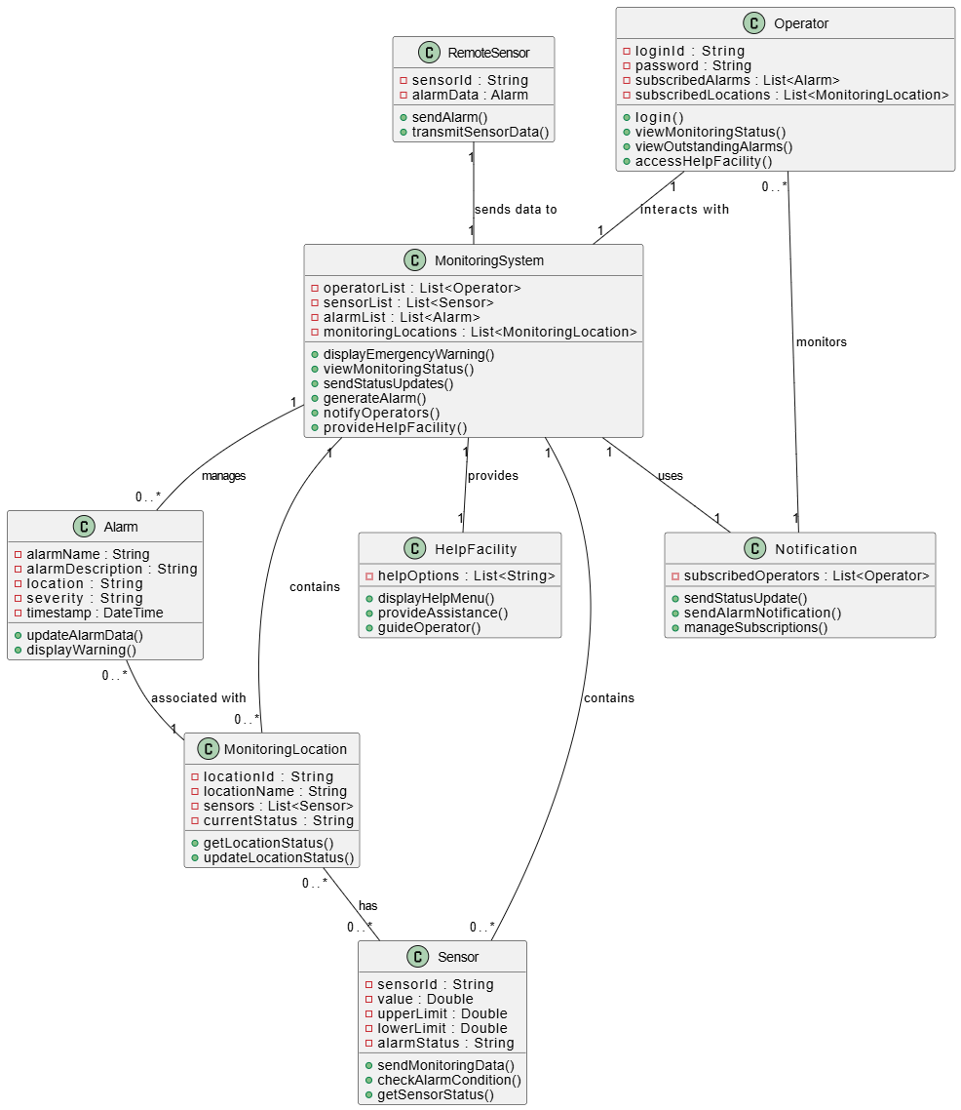

Class Diagram (GPT)

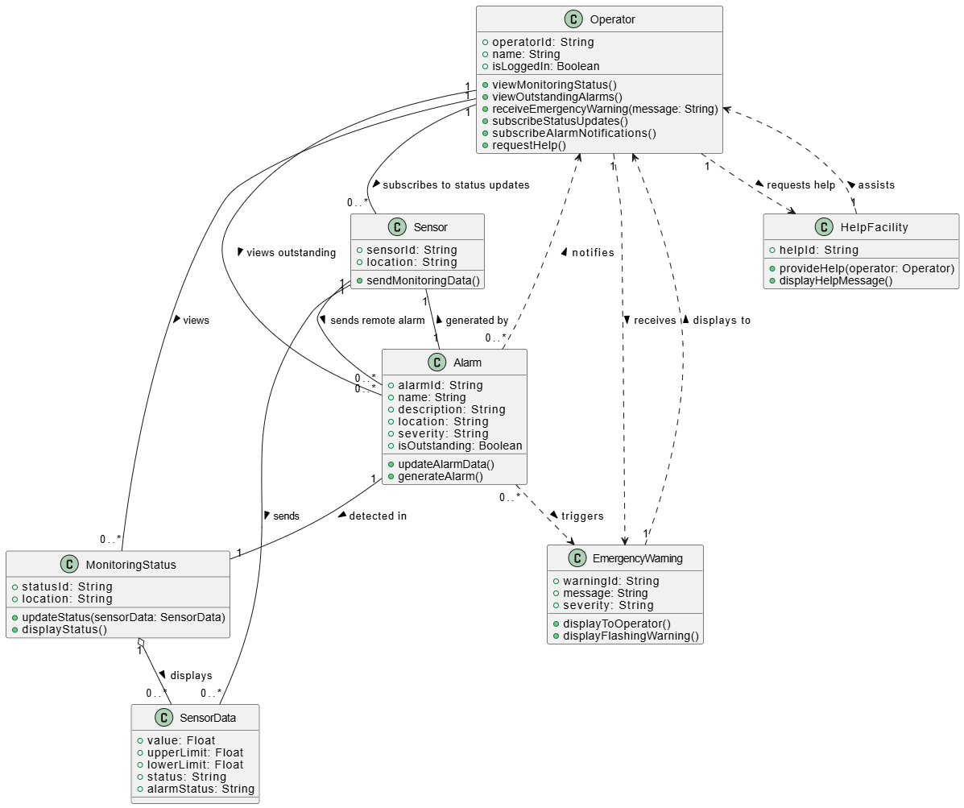

Sequence Diagram (VeriGen)

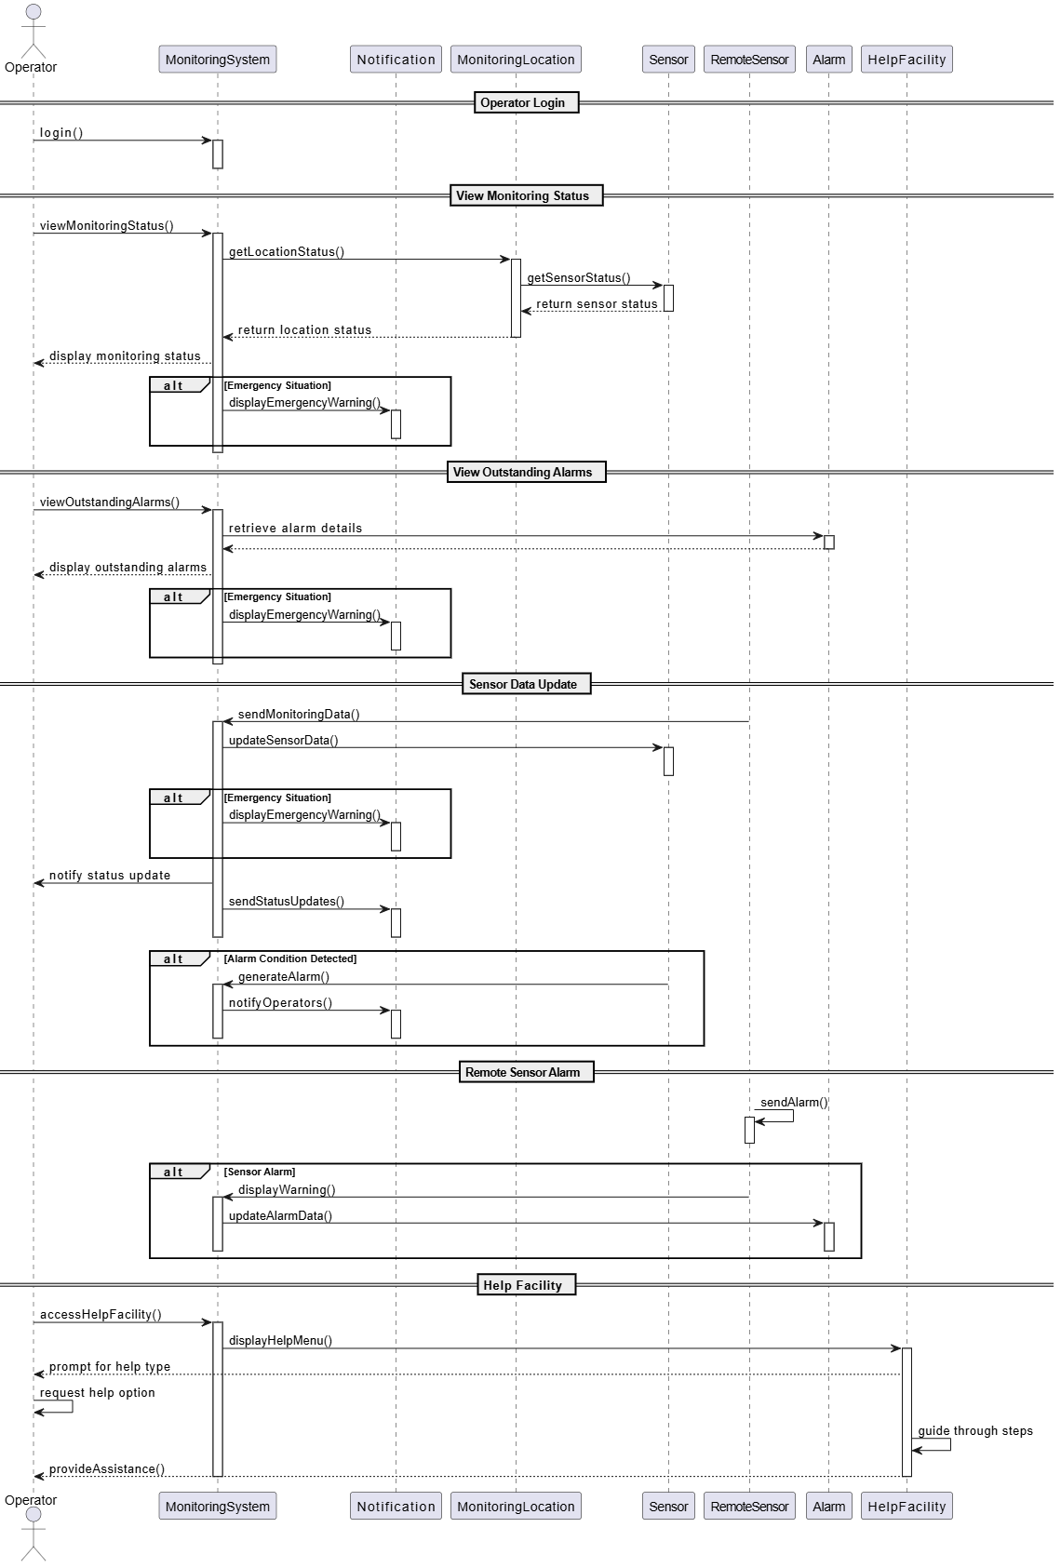
Sequence Diagram (GPT)
